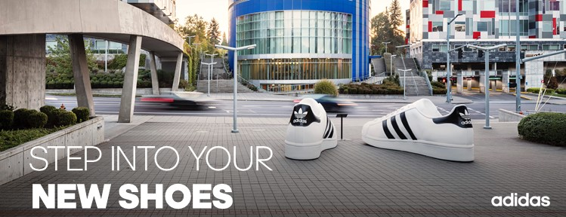

**Calling all creators!**

|  |  |
| --- | --- |
| **지원 매장** | **퍼포먼스 명동** |
| **근무 유형** | **Assistant Store Manager (부점장)** |
| **지원 경로** | **알바몬** |

**1.Personal data (인적사항)**

|  |  |  |  |  |
| --- | --- | --- | --- | --- |
| **한글 이름** | Choose an item. | **성별** | **MALE (남성)** |  |
| **영문 이름** | Choose an item. | **생년월일** | Choose an item. |
| **연락처** | Choose an item. | **이메일 주소** | Choose an item. |
| **주소** | Choose an item. | | |
| **보훈대상 여부** | **해당없음** | **장애판정 여부** | **해당없음** |

**2. Academic ability (학력사항)**

|  |  |  |
| --- | --- | --- |
| **학교명** | **학과** | **재학 여부** |
| Choose an item. **고등학교** | Choose an item. | **해당없음** |
| Choose an item. **대학교/대학원** | Choose an item. | **해당없음** |

**3. Work Experience (경력사항)**

|  |  |  |  |  |
| --- | --- | --- | --- | --- |
| **회사명** | **근무 기간** | **직책** | **업무 내용** | **연봉** |
| Choose an item. | Choose an item. | Choose an item. | Choose an item. | Choose an item. |
| Choose an item. | Choose an item. | Choose an item. | Choose an item. | Choose an item. |
| Choose an item. | Choose an item. | Choose an item. | Choose an item. | Choose an item. |
| Choose an item. | Choose an item. | Choose an item. | Choose an item. | Choose an item. |

**4. Reason for application (지원동기)**

|  |
| --- |
|  |

**5. Self-Introduction (경력위주로 상세히 기술)**

|  |
| --- |
|  |